**Assignment 3**

**Name**: Hemavarshini B

**Roll No**: 718019Z217

**Project**: Inventory management system for retailers

HTML:

<html lang="en">

<head>

    <meta charset="UTF-8">

    <meta http-equiv="X-UA-Compatible" content="IE=edge">

    <meta name="viewport" content="width=device-width, initial-scale=1.0">

    <title>IBM cloud storage images</title>

    <link rel="stylesheet" href="https://picture-bucket-storage.s3.jp-tok.cloud-object-storage.appdomain.cloud/image.css">

</head>

<body>

    <img src="https://picture-bucket-storage.s3.jp-tok.cloud-object-storage.appdomain.cloud/ibm1.jpg" alt="wallpaper_1">

    <img src="https://picture-bucket-storage.s3.jp-tok.cloud-object-storage.appdomain.cloud/ibm2.jpg" alt="wallpaper_2">

    <img src="https://picture-bucket-storage.s3.jp-tok.cloud-object-storage.appdomain.cloud/ibm3.jpg" alt="wallpaper_3">

    <img src="https://picture-bucket-storage.s3.jp-tok.cloud-object-storage.appdomain.cloud/ibm4.jpg" alt="wallpaper_4">

    <img src="https://picture-bucket-storage.s3.jp-tok.cloud-object-storage.appdomain.cloud/ibm5.jpg" alt="wallpaper_5">

</body>

</html>

**CSS**

html{

    background-color: rgb(43, 43, 43);

}

body {

    display: flex;

    flex-wrap: wrap;

    gap: 100px;

    justify-content: center;

    align-items: center;

}

img {

    width: 25%;

}

**CLOUD OBJECT STORAGE**



**WATSON ASSISTANT**

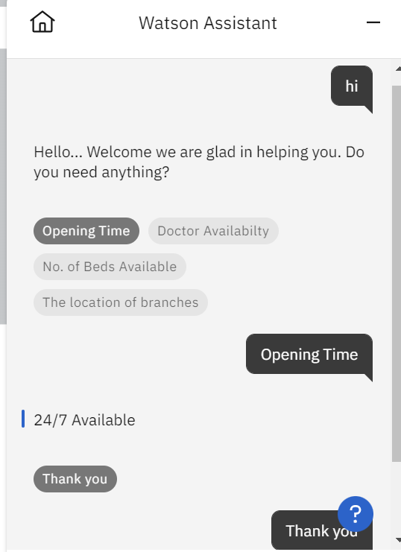

**CHATBOT LINK**

<https://web-chat.global.assistant.watson.appdomain.cloud/preview.html?backgroundImageURL=https%3A%2F%2Fau-syd.assistant.watson.cloud.ibm.com%2Fpublic%2Fimages%2Fupx-66b15ede-1876-4a49-a0ca-35bfe0022558%3A%3A69f24cab-016d-493b-8242-accfd69284eb&integrationID=d98a68ad-daba-4191-bd18-b01f59e1baa0&region=au-syd&serviceInstanceID=66b15ede-1876-4a49-a0ca-35bfe0022558>